|  |  |
| --- | --- |
| Nikon AF-S 70-200mm f/2.8E FL ED VR lens  Ống kính Nikon AF-S 70-200mm f/2.8E FL ED VR  Nikon AF-S NIKKOR 70-200mm f2.8E FL ED VR 1 Nikon AF-S NIKKOR 70-200mm f2.8E FL ED VR 5 Nikon AF-S NIKKOR 70-200mm f2.8E FL ED VR 6 Nikon AF-S NIKKOR 70-200mm f2.8E FL ED VR 7 | **Featured information:**  Format: Nikon F-Mount / FX  Aperture: f/2.8 - f/22  Six extra-low dispersion elements  Fluorite lenses and HRI  Price : $ 2100  **Specifications:**  Focal distance  70 - 200mm  Largest Aperture  f/2.8  Smallest Aperture  f/22  Lens Mount  Nikon F  Lens Format  Full-Frame  View  34° 20' - 12° 20'  Minimum Focus Distance  1.1m  Magnification  0.21x  Optical Components  22 Elements in 18 Groups  Number of Mouth Blades  9  Focus Type  Autofocus  Anti-Vibration |

**Overview:**

The Nikon AF-S NIKKOR 70-200mm f/2.8E FL ED VR lens is a DSLR lens designed for use with Nikon FX sensor cameras. This lens can also be used with DX sensors, providing a 105-300mm equivalent focal length. The sealed design and magnesium alloy construction allow the Nikon AF-S NIKKOR 70-200mm f/2.8E FL ED VR to withstand dust and moisture when working in harsh environments.

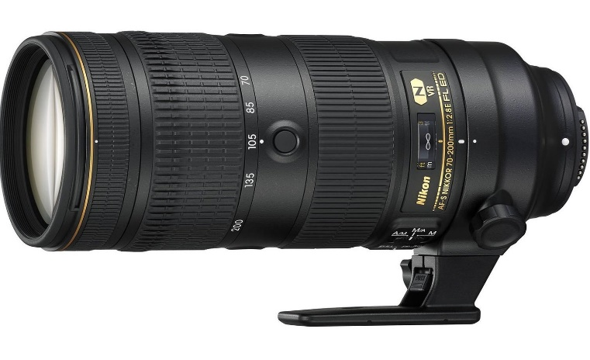

Six extra-low dispersion elements combine with one fluorite element and an HRI (high refractive index) element in the Nikon AF-S NIKKOR 70-200mm f/2.8E FL ED VR to significantly reduce flare. false color and color fringing, as well as increased image contrast, clarity and sharpness. A constant f/2.8 aperture across the range provides consistent performance and also benefits working in difficult lighting conditions.

Nano Crystal Coat and Super Integrated Coating applied to lens elements correct surface and internal light reflections to reduce flare and ghosting. Fluoride coatings on the front and rear protect the optical system from dirt, moisture and grease.

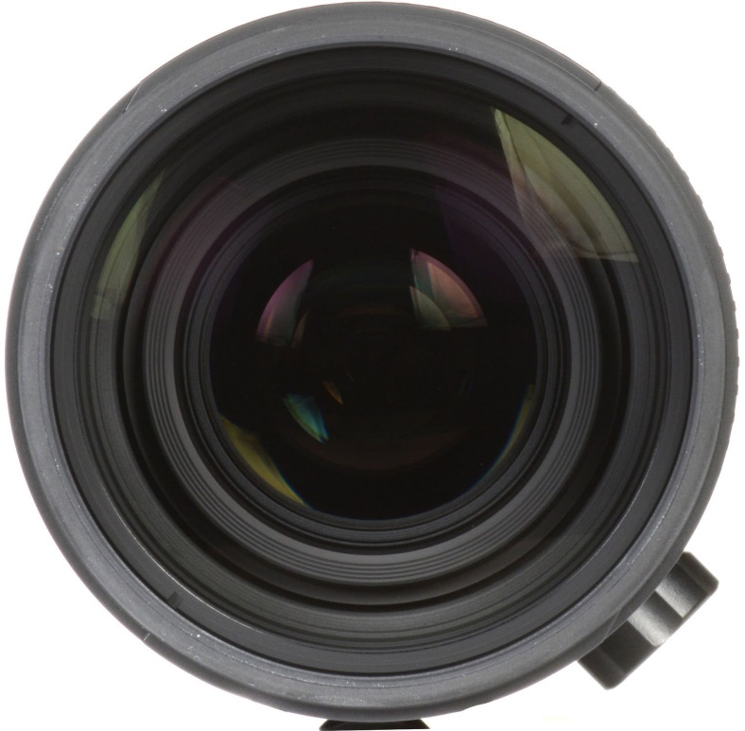

Silent Wave Motor delivers fast, quiet, and precise autofocus performance along with full-time manual focus control. An internal focusing design is also used, which maintains the overall length of the lens and supports faster focusing speeds. Four focus buttons are equipped on the lens for easy AF Lock activation.

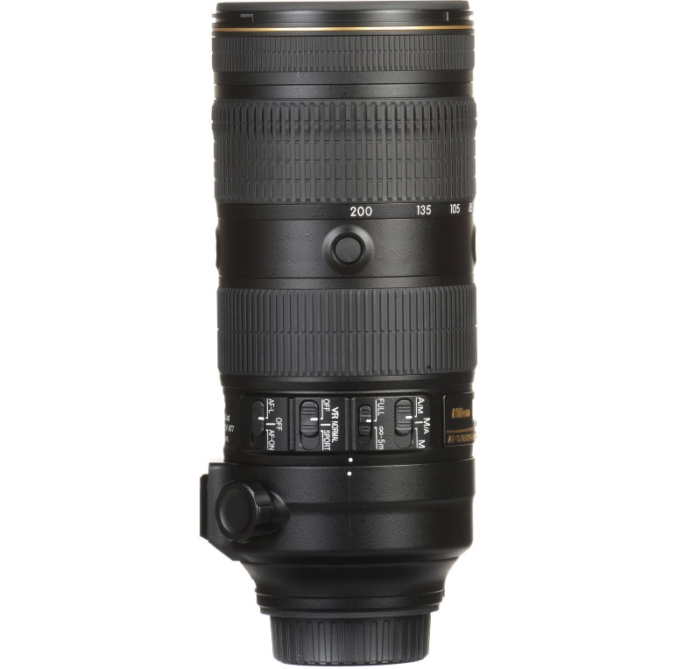

The minimum focusing distance of the lens has been shortened from 1.4 m to 1.1 m. At the same time, the zoom capability increases from 0.11x to 0.21x for improved performance. As a result, you can get closer to subjects to focus, resulting in images similar to close-up shots.